
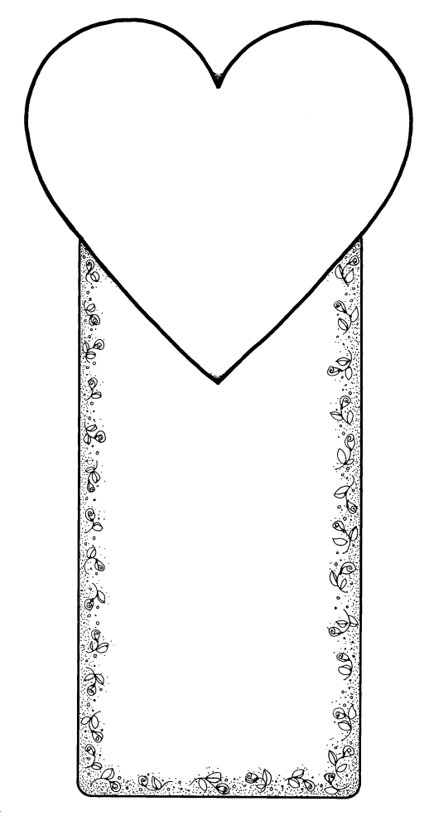

The Five Love Languages

~Quality Time ~
~Words of Affirmation ~
~ Receiving Gifts ~ Acts of Service ~
~Physical Touch~

The Five Love Languages

~Quality Time ~
~Words of Affirmation ~
~ Receiving Gifts ~ Acts of Service ~
~Physical Touch~

The Five Love Languages

~Quality Time ~
~Words of Affirmation ~
~ Receiving Gifts ~ Acts of Service ~
~Physical Touch~

The Five Love Languages

~Quality Time ~
~Words of Affirmation ~
~ Receiving Gifts ~ Acts of Service ~
~Physical Touch~

The Five Love Languages

~Quality Time ~
~Words of Affirmation ~
~ Receiving Gifts ~ Acts of Service ~
~Physical Touch~

The Five Love Languages

~Quality Time ~
~Words of Affirmation ~
~ Receiving Gifts ~ Acts of Service ~
~Physical Touch~

