Book of Mormon
Scripture Mastery Sorting Game
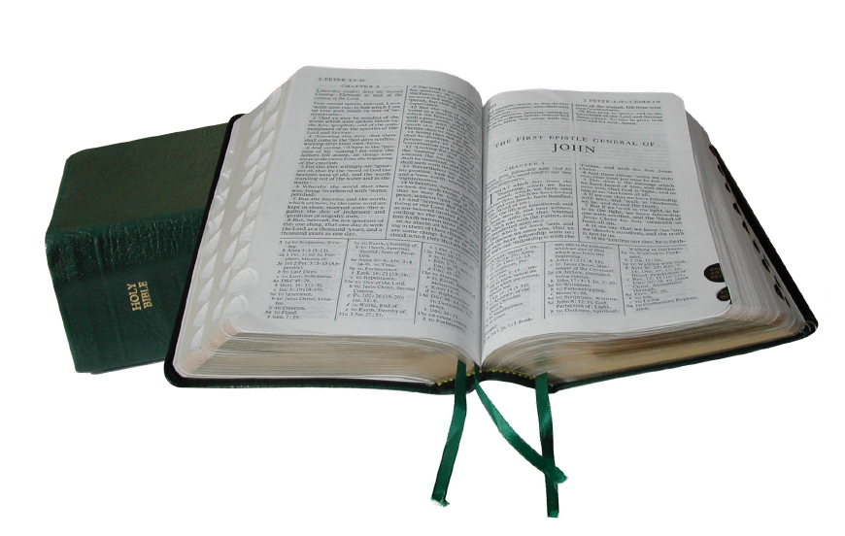
Cut along the dotted lines and match scripture mastery key phrases with each reference.

In my class, we only cut out the keyphrases, leaving the scripture references as one list so that things stay in good order. Slips are stored in a zipper baggie in their binders.

You may have students sort the scripture mastery passages during opening exercises. They can race for a prize or for a space on the leader board.

This and other Free LDS Seminary handouts from MormonShare.com
1 Nephi 3:7 | “... I will go and do the things which the Lord has commanded ...”
2 Nephi 2:25 | “Adam fell that men might be; men are that they might have joy.”
2 Nephi 2:27 | “...men are free according to the flesh ...”
2 Nephi 9:28–29 | "… When they are learned they think they are wise ...”
2 Nephi 25:23, 26 | “... and we talk of Christ, we rejoice in Christ, we preach of Christ, we prophesy of Christ ...”
2 Nephi 28:7–9 | “... there shall be many which shall say: Eat, drink, and be merry, for tomorrow we die...”
2 Nephi 31:19–20 | “... press forward with a steadfastness in Christ, having a perfect brightness of hope, and a love of God and of all men.”
2 Nephi 32:3 | “... feast upon the words of Christ; for behold, the words of Christ will tell you all things what ye should do.”
2 Nephi 32:8–9 | “... ye must pray; for the evil spirit teacheth not a man to pray...”
Mosiah 2:17 | “... when ye are in the service of your fellow beings ye are only in the service of your God.”
Mosiah 3:19 | “... the natural man is an enemy to God ...”
Mosiah 4:30 | “... watch yourselves, and your thoughts, and your words, and your deeds...”
Alma 7:11–13 | “...he will take upon him the pains and the sicknesses of his people. And he will take upon him death, that he may loose the bands of death“
Alma 32:21 | “...faith is not to have a perfect knowledge of things; therefore if ye have faith ye hope for things which are not seen, which are true.”
Alma 37:35 | “O, remember, my son, and learn wisdom in thy youth; yea, learn in thy youth to keep the commandments of God..”
Alma 39:9 | “... repent and forsake your sins, and go no more after the lusts of your eyes ...”
Alma 41:10 | “...wickedness never was happiness.”
Helaman 5:12 | “...remember, remember that it is upon the rock of our Redeemer, who is Christ, the Son of God, that ye must build your foundation”
3 Nephi 12:48 | “Therefore I would that ye should be perfect even as I, or your Father who is in heaven is perfect.”
3 Nephi 18:15, 20–21 | “...whatsoever ye shall ask the Father in my name, which is right, believing that ye shall receive, behold it shall be given unto you.”
Ether 12:6 | “...ye receive no witness until after the trial of your faith.”
Ether 12:27 | “...I make weak things become strong unto them.”
Moroni 7:41 | “... ye shall have hope through the atonement of Christ and the power of his resurrection ...”
Moroni 7:45, 47–48 | “ … charity is the pure love of Christ ...”
Moroni 10:4–5 | “... by the power of the Holy Ghost ye may know the truth of all things.

