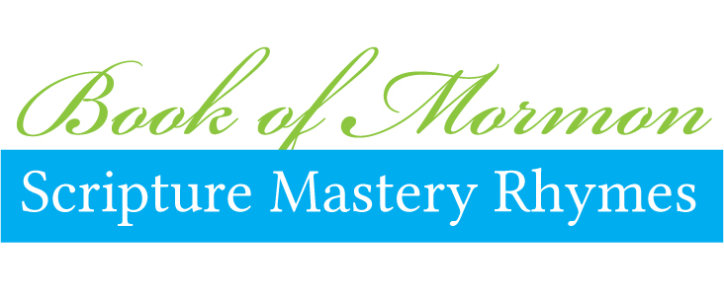

Scripture | First 4 beats | Second 4 beats
1 Nephi 3:7 | First  Nephi  Three  Seven | Go,  Do,  Follow  Direction
2 Nephi 2:25 | Second  Nephi  two twenty-  five | Adam  fell and  we'll re-  vive.
2 Nephi 2:27 | Second  Nephi  Two  Twenty-seven | Free to  choose:  Hell or  Heaven
2 Nephi 9:28–29 | Second Nephi  Nine twenty-  eight twenty-  nine | Listen to  God and  you'll be  wise.
2 Nephi 25:23, 26 | Second  Nephi  twenty-  five | Talk,re-  joice, and  preach of  Christ.
2 Nephi 28:7–9 | Second Neph-  i twenty-eight  seven and  nine | Eat, drink and be  merry For to-  morrow we  die.
2 Nephi 31:19–20 | Second Nephi  Thirty-one  Nineteen  Twenty | Press foward, en-  dure, and  don't get  testy.
2 Nephi 32:3 | Second  Nephi  Thirty-two  Three | Words of  Christ--  on them we  feast.
2 Nephi 32:8–9 | Second Neph-  i thirty-two  eight and  nine | Satan says  no, but  prayer is di-  vine.
Mosiah 2:17 | Mosiah  two  seven-  teen | Serve God by  serving your  fellow-  being.
Mosiah 3:19 | Mosiah  three  nine-  teen | Natural  man: God's  ene-  my.
Mosiah 4:30 | Mosiah  four  thir-  ty | Please watch your  thoughts,  words,  deeds.
Alma 7:11–13 | Alma  seven e-  leven thir-  teen | Through Christ  pain and  sin are re-  lieved.
Alma 32:21 | Alma  thirty  two twenty  one | Hope un-  seen  our Faith is be-  gun.
Alma 37:35 | Alma thir-  ty  seven thirty  five | Learn wis-  dom  early in your  life.
Alma 39:9 | Alma  thirty-  nine verse  Nine | Go no more  after the  lusts of your  eyes.
Alma 41:10 | Alma  Forty-  one verse  ten | Wickedness,  happiness  never has  been.
Helaman 5:12 | Hela-  man  five verse  twelve | Build on  Christ;  protect your-  self.
3 Nephi 12:48 | Third Nephi  twelve  forty-  eight | “Be perfect,”  Christ did  surely  state.
3 Nephi 18:15, 20–21 | Third Nephi  eighteen, fif-  teen twenty and  one | Whatever you  ask in  prayer, will be done
Ether 12:6 | Ether  twelve  verse  six | Trial of  faith:  wit-  ness.
Ether 12:27 | Ether  twelve  twenty  seven | Weakness-  es  God will  strengthen.
Moroni 7:41 | Moroni  seven  forty  one | Atonement brings  life through  faith in God’s  Son.
Moroni 7:45, 47–48 | Moroni  seven forty  five, seven,  eight | Chari-  ty  knows no  hate.
Moroni 10:4–5 | Moroni  ten verse  four and  five | Find the  truth by  asking  Christ.
These rhymes were created in online collaboration by Jenny Smith, Jeanette Peterson. and Leslie Woolf.

Get more free Seminary ideas ans share yours at http://MormonShare.com/

