Sacrament Meeting Program ~ 2010

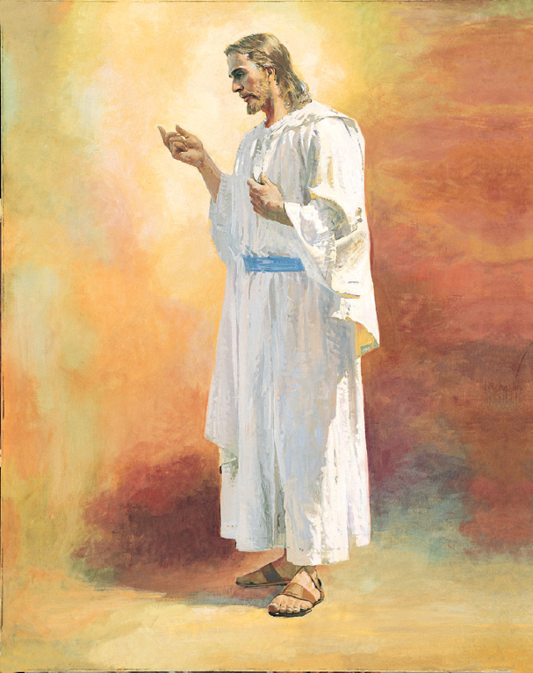

I KNOW MY SAVIOR LIVES
(Worksheet)

This is a worksheet that allows leaders to let Primary children “write” the Sacrament Meeting Program themselves.

Each child/class is given a topic (see below) and invited to share his or her feelings about the topic, with some guidance by leaders and teachers. A leader then types up the program and gives a copy to each leader and teacher. Individual parts are given to parents of children to practice at home.

Those children giving talks may need more time or prefer to write their talks at home.

The leader that came up with this method held 2 classes behind each Sunday after opening exercises for 10 minutes and let them work on their parts (reminding teachers in advance). In that way, working on the program didn’t take time away from Sharing Time and was minimally intrusive on class time.

Some younger children may simply restate the topic, and that's fine. You may wish to assign older children the discussion-style questions.

This is the method used by a J. Larsen in the Bloomington 2nd Ward. She provided a copy of her 2005 version, and I have altered it into a form that I hope any Primary can adapt for use in planning tis year's sacrament meeting program.

This file came from http://www.MormonShare.com/
Free LDS Clipart and Lesson Help

I KNOW MY SAVIOR LIVES

The primary children sit quietly and hum I Know That My Savior Loves Me
as the leaders stand at the podium together saying each of their parts.

Primary Leader: This year the children in our Primary had the opportunity to learn to feel and understand the great love that our Savior, Jesus Christ, has for them. They have learned about the central role of Jesus Christ in our Heavenly Father’s plan, and they have learned they can have faith in him. Each child's faith can grow stronger as they keep the commandments, serve, share the gospel, follow the example of the Savior, and prepare for his Second Coming.

Primary Leader: To prepare for this sacrament presentation, each child has been given a topic from this year's theme, I know my Savior lives. Our children's answers to those questions will be as unique as we are. Some might share a personal experience while others of us a direct response in our own words. We invite you to ponder these questions and the messages about how we will follow God’s plan in what we say and sing.

*All children rise and sing I Know That My Savior Loves Me*

Speaker: Recites Article of Faith 1

Speaker: God is the Father of my Spirit

Speaker: Jesus Christ is the Son of God

Speaker: Heavenly Father and Jesus Christ love me.

Sing: He Sent His Son, CS 34

Speaker: Recites Third Article of Faith

Speaker: Jesus Christ is my Savior and Redeemer

Speaker: Through the Atonement of Christ, all mankind may be saved.

Speaker: Jesus Christ was resurrected, and I will be, too.

Talk: How I know that Jesus Christ is my Savior and Redeemer

Speaker: Prophets are called by God.

Speaker: Prophets testify of Jesus Christ.

Speaker: There is safety in following the Prophet.

Speaker: God speaks through prophets

Sing: Follow the Prophet, CS 110

Speaker: What have you learned about when Heavenly Father and Jesus Christ appeared to Joseph Smith?

Speaker: What have you learned about Joseph Smith and the translation of the Book of Mormon?

Speaker: Describe some of the things Jesus Christ restored through Joseph Smith (scriptures, revelation, church organization, prophets, temples, vicarious work, priesthood).

Speaker: Describe how your faith in Jesus Christ is strengthened when you are obedient.

Speaker: Describe how we can repent.

Speaker: Describe the baptismal covenants

Talk: Baptism (Child will tell about his recent baptism).

Speaker: Recite Moroni 10:5

Speaker: What does it mean when we say “When I am confirmed, I receive the gift of the Holy Ghost”?

Speaker: The Holy Ghost is the third member of the Godhead.

Speaker: The Holy Ghost speaks in a still, small voice.

Talk: Describe a time when you felt guided or protected by the Holy Ghost.

Sing: The Holy Ghost, CS 105

Speaker: My love for Jesus Christ grows when I pray.

Speaker: Jesus Christ always obeyed Heavenly Father. I will follow Jesus' example of following his father by .....

Speaker: Jesus Christ went about doing good. I will follow Jesus' example of doing good by .....

Talk: Child will tell the story of one of Jesus' miracles in his/her own words.

Talk: Child will describe how temple work can help families come unto Christ.

Talk: Child will describe how keeping the commandments shows love for Jesus Christ.

Closing remarks: by Bishopric, Branch Presidency, or Primary Presidency.

Closing Song: Come, Follow Me, Hymn 116
**Congregation joins in on last verses**

Group 1

“We Believe in God The Eternal Father, and in His Son, Jesus Christ and in the Holy Ghost…”

Speaker: God is the Father of my Spirit

Speaker: Jesus Christ is the Son of God

Speaker: Heavenly Father and Jesus Christ love me.

Speaker: Can recite Article of Faith 1

Group 2

“Jesus Christ is My Savior and Redeemer”

Speaker: Jesus Christ is my Savior and Redeemer

Speaker: Through the Atonement of Christ, all mankind may be saved.

Speaker: Jesus Christ was resurrected, and I will be, too.

Speaker: Recites Third Article of Faith

Talk: How do you know that Jesus Christ is the Savior and Redeemer?

Group 3

“God Speaks Through Prophets”

Speaker: Prophets are called by God.

Speaker: Prophets testify of Jesus Christ.

Speaker: There is safety in following the Prophet.

Speaker: God speaks through prophets

Group 4

“Jesus Christ Restored the Fulness of the Gospel through Joseph Smith”

Speaker: What have you learned about when Heavenly Father and Jesus Christ appeared to Joseph Smith?

Speaker: What have you learned about Joseph Smith and the translation of the Book of Mormon?

Speaker: Describe some of the things Jesus Christ restored through Joseph Smith (scriptures, revelation, church organization, prophets, temples, vicarious work, priesthood).

Group 5

“Principles and Ordinances of the Gospel Lead me to Jesus Christ”

Speaker: Describe how your faith in Jesus Christ is strengthened when you are obedient.

Speaker: Describe how we can repent.

Speaker: Describe the baptismal covenants

Speaker: What does it mean when we say “When I am confirmed, I receive the gift of the Holy Ghost”?

Talk: Baptism (Child will tell about his recent baptism).

Group 6

“The Holy Ghost Testifies of the Truth of all Things”

Speaker: The Holy Ghost is the third member of the Godhead.

Speaker: The Holy Ghost speaks in a still, small voice.

Talk: Describe a time when you felt guided or protected by the Holy Ghost.

Speaker: Recite Moroni 10:5

Group 7

“I can follow Jesus Christ's Example”

Speaker: Jesus Christ always obeyed Heavenly Father. I will follow Jesus' example of following his father by .....

Speaker: Jesus Christ went about doing good. I will follow Jesus' example of doing good by .....

Group 8

“Jesus Christ is the Son of God, and he is a God of Miracles”

Talk: Child will tell the story of one of Jesus' miracles in his/her own words.

Talk: Child will desribe how temple work can help families come unto Christ.

Group 9

“I obey Jesus Christ because I love him”

Talk: Child will describe how keeping the commandments shows love for Jesus Christ.

Speaker: My love for Jesus Christ grows when I pray.

